Project Sprint #3
The SOS game is described in CS449HomeworkOverview.docx. You should read the description very carefully.

Your submission must include the GitHub link to your project and you must ensure that the instructor has the proper access to your project. You will receive no points otherwise.

GitHub link: https://github.com/mohamede2022/SOS-game/tree/main/Sprint%203

Implement all the features that support a human player to play a simple or general SOS game against a human opponent and refactor your existing code if necessary. The minimum features include choosing the game mode (simple or general), choosing the board size, setting up a new game, making a move (in a simple or general game), and determining if a simple or general game is over. The following is a sample GUI layout. It is required to use a class hierarchy to deal with the common requirements of the Simple Game and the General Game. If your code for Sprint 2 has not considered class hierarchy, it is time to refactor your code.

SOS Simple game General game Board size
8
Blue player  S  O | 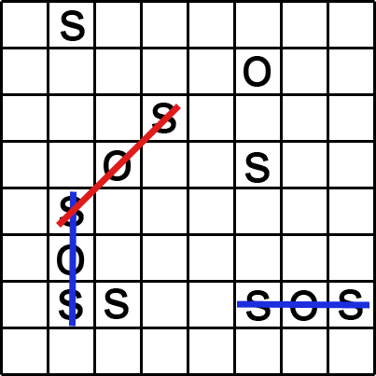 | Red player  S  O
 | Current turn: blue (or red) | New Game
Figure 1. Sample GUI layout of the working program for Sprint 3

Deliverables: expand and improve your submission for sprint 2.

- Demonstration (9 points)
Submit a video of no more than five minutes, clearly demonstrating the following features.
- A simple game that the blue player is the winner
- A simple draw game with the same board size as (a)
- A general game that the red player is the winner, and the board size is different from (a)
- A general draw game with the same board size as (c)
- Some automated unit tests for the simple game mode
- Some automated unit tests for the general game mode
In the video, you must explain what is being demonstrated.

Video Link: https://umsystem.hosted.panopto.com/Panopto/Pages/Viewer.aspx?id=70cb9730-6b29-4d07-bfeb-b38c003e1349

- Summary of Source Code (1 points)

Source code file name | Production code or test code? | # lines of code
Board.py | Production code | 30
player.py | Production code | 15
controller.py | Production code | 33
gui_main.py | Production code | 90
gui_board.py | Production code | 45
SOSGame.py | Production code (New) | 90
SimpleGame.py | Production code (New) | 18
GeneralGame.py | Production code (New) | 25
Test_board.py | Test code | 17
test_player.py | Test code | 14
test_controller.py | Test code | 15
test_gui_board.py | Test code | 10
test_game_simple.py | Test code (New) | 60
test_game_general.py | Test code (New) | 55
Total |  | 517

Note: The core expansion from Sprint 2 was the structural change for the distinct logic of the Simple Game (sudden death win) in SimpleGame.py and the General Game (scoring and full-board end) in GeneralGame.py to coexist cleanly. I also added dedicated unit tests (test_game_simple.py, test_game_general.py) to confirm that each mode correctly enforced. I updated some of the previous sprint 2 code so it matches the added logic.

You must submit all source code via github to get any credit for this assignment.

- Production Code vs User stories/Acceptance Criteria (3 points)

Summarize how each of the user story/acceptance criteria is implemented in your production code (class name and method name etc.)

User Story ID | User Story Name
1 | Choose a board size
2 | Choose the game mode of a chosen board
3 | Start a new game of the chosen board size and game mode
4 | Make a move in a simple game
5 | A simple game is over
6 | Make a move in a general game
7 | A general game is over

User Story ID | AC ID | Class Name(s) | Method Name(s) | Status (complete or not) | Notes (optional)
1 | 1.1 | gui_main.py | __init__, create_widgets | Complete
2 | 2.1 | gui_main.py | __init__, create_widgets | Complete | Uses tk.Radiobutton and mode_var for the selections.
3 | 3.1 | gui_main.py, controller.py | start_new_game, start_new_game | Complete | Controller initiates SimpleGame or GeneralGame based on selection.
4 | 4.1 | gui_board.py, SOSGame.py | handle_click, make_move | Complete | Base class method handles the move, including SOS check.
5 | 5.1 | SimpleGame.py | is_game_over, check_game_end | Complete | Game ends after first SOS is scored, or board is full.
6 | 6.1 | gui_board.py, SOSGame.py | handle_click, make_move | Complete | Same mechanism as Simple Game, but scoring is internal.
7 | 7.1 | GeneralGame.py | is_game_over, check_game_end | Complete | Game ends only when the board is full.

- Tests vs User stories/Acceptance Criteria (2 points)

Summarize how each of the user story/acceptance criteria is tested by your test code (class name and method name) or manually performed tests.

User Story ID | User Story Name
1 | Choose a board size
2 | Choose the game mode of a chosen board
3 | Start a new game of the chosen board size and game mode
4 | Make a move in a simple game
5 | A simple game is over
6 | Make a move in a general game
7 | A general game is over

4.1 Automated tests directly corresponding to some acceptance criteria

User Story ID | Acceptance Criterion ID | Class Name (s) of the Test Code | Method Name(s) of the Test Code | Description of the Test Case (input & expected output)
4 | 4.1 | test_game_simple.py | test_win_condition_vertical | Input: A series of moves to form an S-O-S vertically. Expected: is_game_over() returns True.
5 | 5.1 | test_game_simple.py | test_draw_condition | Input: Filling the board without forming any SOS. Expected: is_game_over() returns True and get_winner() returns "Draw".
6 | 6.1 | test_game_general.py | test_multiple_sos_scoring | Input: Two SOS for Blue, one for Red. Expected: Blue's score is 2, Red's score is 1.
7 | 7.1 | test_game_general.py | test_general_game_winner | Input: Filling a 3x3 board where Red scores more SOS. Expected: is_game_over() is True, get_winner()returns "Red".

4.2 Manual tests directly corresponding to some acceptance criteria

User Story ID | Acceptance Criterion ID | Test Case Input | Test Oracle (Expected Output) | Notes
1 | 1.1 | Enter board size 8 and click New Game. | An 8x8 grid of empty buttons appears. | Confirms the dynamic board generation.
2 | 2.1 | Select "General" radio button | Game starts as a General Game; winner is only determined when the board is full. | Confirms mode specific rules are applied.
3 | 3.1 | Select size 4, Mode Simple, click New Game. | Current Turn label reads "Current Turn: Blue"[cite: 100], and the board is empty 4x4. | Confirms the game can setup properly.

- (Part 1) Describe how the class hierarchy in your design deals with the common and different requirements of the Simple Game and the General Game.
At least 1/2 page, excluding screenshots/diagrams (12pt, single-spaced), is required. (3 Points)
My SOS game design meets the requirement for using a class hierarchy by structuring the game logic around an Abstract Base Class (ABC) called SOSGame.py. This architecture separates the universal rules that apply to every game from the specific rules that define the Simple and General modes. Then subclasses like GeneralGame.py and SimpleGame.py inherit from the base class SOSGame.py.

Common Requirements (Inheritance)
All shared game mechanics are defined in the SOSGame.py base class. By using Inheritance, the specialized game modes automatically get this functionality, saving us the trouble from writing the same code twice. Main Game Actions: The base class handles placing a letter on the board and checking for scores. The check_for_sos() method is defined once here, it runs the complex logic to scan all directions to detect an S-O-S sequence and update the scoring player's tally, regardless of the game mode. Move Flow: The make_move() method serves as the universal entry point. It places the letter, checks for scores, and then calls the mode specific termination logic before deciding if the turn should switch. This guarantees a consistent game process across all modes.

Different Requirements (Polymorphism)
The unique rules for each game mode are handled using Polymorphism, meaning the subclasses provide their own implementation for certain methods, even though the base class defines the structure.
Simple Game (SimpleGame.py): This class implements the sudden death rule. Its check_game_end() method is the key difference, it immediately flags the game as over (self._is_over = True) the instant an SOS is formed. This state change forces the base class's make_move() to bypass the turn switch, making the winning move the final action of the game. The get_winner() method simply returns the player who caused this instant termination.
General Game (GeneralGame.py): This class implements the accumulation rule. Its is_game_over() method is overridden to return True only when the entire board is full, allowing players to rack up multiple scores throughout the game. Furthermore, the base class's logic is used to skip the turn toggle when a player scores, correctly giving them an extra turn. This rule is specific to the General Mode. The get_winner() method then compares the final score totals to declare the overall winner.
This hierarchy ensures that the core rules are always correct, while the game flow adapts seamlessly to either the instant win or the full board scoring requirements based on the mode selected.
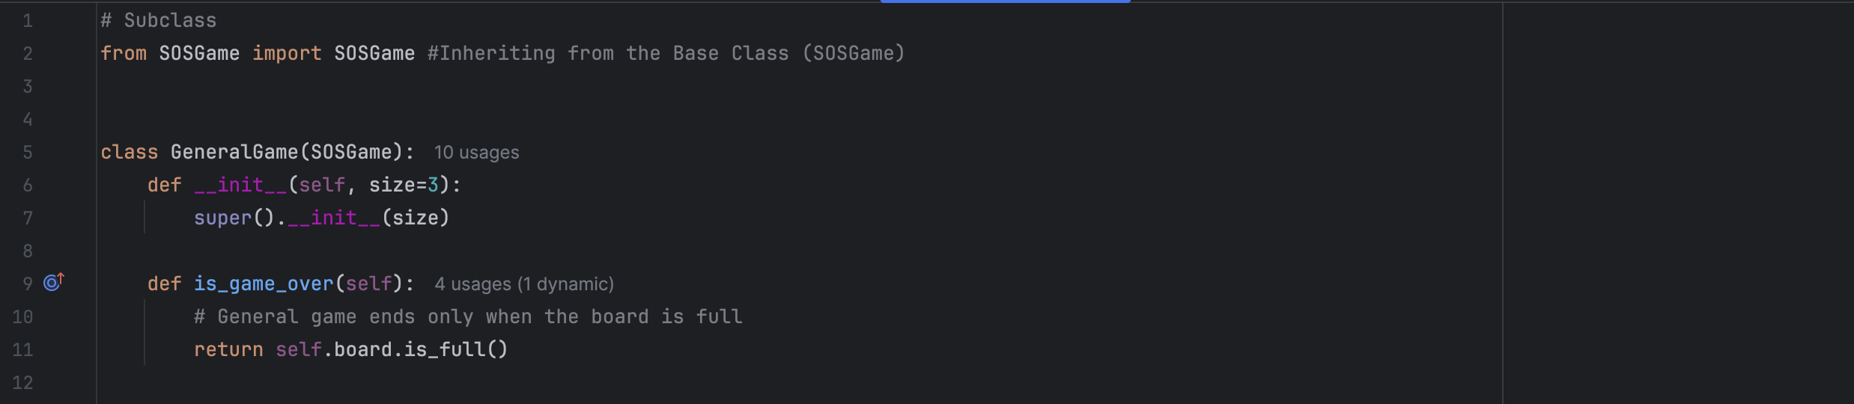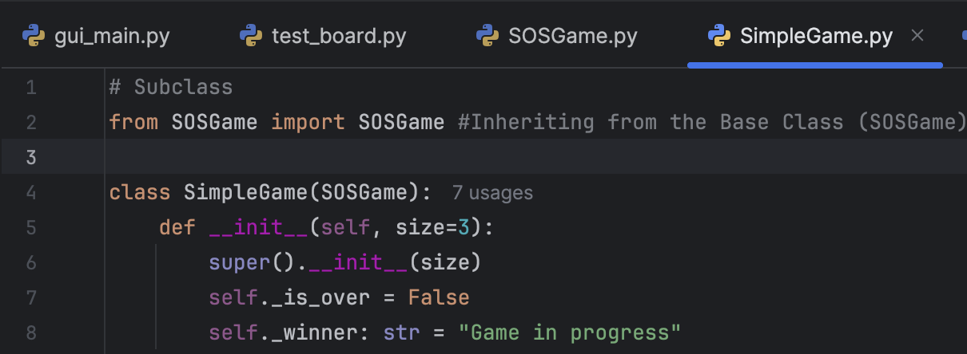

(Part 2) Demonstrate how you use LLM (ChatGPT or other) to analyze how well your code adheres to the design principles discussed in class - modularity, cohesion, coupling, and encapsulation – using the definitions provided in class. Provide screenshots of your interactions with the LLM, showing the prompts used and the responses received.
Interpret the LLM’s feedback, refine your prompts if needed to obtain more relevant responses, and discuss any changes made to your code based on the analysis. Explain how these refinements improve adherence to the design principles.
At least 1/2 page is required, excluding screenshots (12pt, single-spaced). (2 Points)
The second part of this project required using an LLM to evaluate the design of my refactored SOS Game code. I provided the LLM with my core classes (SOSGame.py hierarchy, controller.py, gui_main.py) and the class definitions for Modularity, Cohesion, Coupling, and Encapsulation to get academic level feedback. The goal was to find and fix any areas where the code didn't perfectly adhere to these principles.

Initial LLM Analysis
My first prompt was broad, asking the LLM to analyze the entire code structure against the four design principles.
Prompt 1: "Analyze the provided Python classes (Model hierarchy, Controller, and View components) against the design principles of Modularity, Cohesion, Coupling, and Encapsulation. Pay close attention to how the GUI interacts with the game logic through the Controller."
The LLM's feedback was mostly positive regarding Modularity and Cohesion, which I expected because I had separated the code into distinct files based on function for example, board.py only handles the grid. However, the LLM flagged a major issue with Coupling and Encapsulation. The LLM specifically called out my gui_main.py file for breaking the Encapsulation of the Model layer. The line in question was inside the set_letter method in the GUI, which handles the radio button clicks, self.controller.game.blue_player.set_letter(letter).
The LLM explained that by using .game.blue_player, the GUI was showing deep knowledge of the Model's internal structure. This creates high coupling because if I ever changed the attribute name blue_player inside my SOSGame class, the GUI would instantly break. The View should only be coupled to the Controller's public methods, not the model's private attributes.

Refinement and Code Improvement
To fix this architectural flaw, I used a second more focused prompt to ask the LLM for the solution to enforce the Controller as a strict intermediary.
Prompt 2: "To reduce coupling, the GUI should not access Model attributes like .game.blue_player. Propose a new public method for the GameController in controller.py that would handle setting player letters, thus hiding the internal logic from gui_main.py."
I implemented the new method the LLM suggested, effectively hiding the blue_player and red_player attributes from the GUI. Change in controller.py: I added a new method to the GameController class. This method is the only layer that is allowed to access the internal self.game object attributes. Changed the definition in the controller file (self.game.blue_player.set_letter(letter)) so that it only inherits when used in the gui_main.py. I replaced the violating line in gui_main.py with the new clean Controller call (self.controller.set_player_letter(color, letter)).
This refinement greatly improved the code's adherence to Coupling and Encapsulation. Improved Encapsulation: The Model's internal data which are the player objects are now fully encapsulated within the Controller/Model boundary. The GUI doesn't know how the player letter is stored, only that the Controller knows how to do it via a public method. Reduced Coupling: The Coupling level between the view (gui_main.py) and the Model (player.py) dropped significantly. The two modules are no longer directly dependent on each other's internal structure. Now, the GUI is only coupled to the Controller's public interface. This is the goal of the model view Controller pattern and makes the entire system more modular and much easier to maintain, as changes in the Model's object structure won't break the GUI. The LLM was very effective at pinpointing this specific design flaw.

